|  |  |  |
| --- | --- | --- |
| Санкт-Петербургский политехнический университет Петра Великого  Институт компьютерных наук и технологий  **Высшая школа программной инженерии** | | |
| **КУРСОВОЙ ПРОЕКТ** | | |
| МОДЕЛИРОВАНИЕ СИСТЕМЫ, ФОРМАЛИЗОВАННОЙ КАК СИСТЕМА МАССОВОГО ОБСЛУЖИВАНИЯ | | |
| по дисциплине «Алгоритмизация и структурное программирование» | | |
| Выполнил | | |
| студент гр. 13534/4 |  | Мащенко Б.Б. |
| Руководитель | | |
| доцент, к.т.н. |  | Веренинов И.А. |
| «25» марта 2019г. | | |
| Санкт-Петербург | | |
| 2019 | | |

ЗАДАНИЕ

НА ВЫПОЛНЕНИЕ КУРСОВОГО ПРОЕКТА

|  |  |  |  |  |  |  |  |  |  |  |  |  |  |
| --- | --- | --- | --- | --- | --- | --- | --- | --- | --- | --- | --- | --- | --- |
| студенту группы | | 13534/4 | |  | Мащенко Богдану Борисовичу | | | | | | | | |
|  | | *(номер группы)* | |  | *(фамилия, имя, отчество)* | | | | | | | | |
| ***1. Тема проекта (работы)*** | | | |  | | | | | | | | | |
| *Разработка программной системы моделирования дискретной стохастической системы, формализованной как одноканальная система массового обслуживания с многомерным входным потоком и памятью заявок с применением технологии ООП* | | | | | | | | | | | | | |
| ***2. Срок сдачи студентом законченного проекта работы)*** | | | | | | | | | | | | | *25 марта 2019 года* |
| ***3. Исходные данные к проекту (работе)*** | | | | | | | | |  | | | | |
| *Перечень индивидуальных заданий на проект с указанием конкретного номера задания*  *Методическое пособие по курсовому проектированию* | | | | | | | | | | | | | |
|  | | | | | | | | | | | | | |
|  | | | | | | | | | | | | | |
|  | | | | | | | | | | | | | |
| ***4.Содержание пояснительной записки***(перечень подлежащих разработке вопросов): введение, основная часть (раскрывается структура основной части), заключение, список использованных источников, приложения)*.* | | | | | | | | | | | | | |
| ***Введение с формулировкой конкретного задания*** | | | | | | | | | | | | | |
| ***Инструкция системного программиста с указанием состава, назначения модулей, особенностей размещения драйверов и т.д.*** | | | | | | | | | | | | | |
| ***Инструкция по запуску, особенностей интерфейса, выводу результатов***  ***Примеры результатов в графической и табличной форме*** | | | | | | | | | | | | | |
| ***Полные исходные тексты всех модулей с комментариями полей данных и методов типов объектов*** | | | | | | | | | | | | | |
| Примерный объем пояснительной записки | | | | | | ***65*** | | | | страниц машинописного | | | |
| текста | | | | | | | | | | | | | |
| 5. Перечень графического материала (с указанием обязательных чертежей и | | | | | | | | | | | | | |
| плакатов) | Нет | | | | | | | | | | | | |
|  | | | | | | | | | | | | | |
| 6. Консультанты | | | Нет | | | | | | | | | | |
|  | | | | | | | | | | | | | |
| 7. Дата получения задания: «11» февраля 2019г. | | | | | | | | | | | | | |
|  | | | | | | | | | | | | | |
| Руководитель | | | | |  | | |  | | | *Веренинов И.А.* | | |
|  | | | | | *(подпись)* | | |  | | | *(инициалы, фамилия)* | | |
| Задание принял к исполнению | | | | |  | |  | | | | *Мащенко Б.Б.* | | |
|  | | | | | *(подпись)* | |  | | | | *(инициалы, фамилия)* | | |
|  | | | | | | | | | | | |  | |
|  | | | | | | | | | | | | *(дата)* | |

Оглавление

Введение 5

Инструкция программиста 6

Инструкция оператора 7

Главное меню 7

Настройка параметров 8

Моделирование 9

Результаты 12

Список использованных источников 15

Приложение 1. Исходный код программы SMO.PAS 16

Приложение 2. Исходный код модуля BOOS.PAS 17

Приложение 3. Исходный код модуля BAS.PAS 23

Приложение 4. Исходный код модуля BUFFER.PAS 25

Приложение 5. Исходный код модуля DEVICE.PAS 27

Приложение 6. Исходный код модуля WRITER.PAS 30

Приложение 7. Исходный код модуля STATIST.PAS 33

Приложение 8. Исходный код модуля SOURCE1.PAS 38

Приложение 9. Исходный код модуля SOURCE2.PAS 40

Приложение 10. Исходный код модуля MENU.PAS 42

Приложение 11. Исходный код модуля SUPM.PAS 46

Приложение 12. Исходный код модуля MENUMOD.PAS 53

Приложение 13. Исходный код модуля MENURES.PAS 59

## Введение

Задача состоит в разработке программной системы моделирования, формализованной как система массового обслуживания (СМО) с двумя входными потоками и памятью заявок с применением технологии ООП.

ДАНО:

* Количество источников - 2
* Потоки заявок - I-простейший , II-равномерный τ1=0.1≤τ≤τ2=0.5
* Объем буфера - 2
* Дисциплина записи в буфер - в порядке поступления с отказами
* Дисциплина выборки из буфера - бесприоритетная
* Поток обслуживания - простейший с λобсл=1 (параметр закона)
* Точность оценки вероятностей - δ=10%, Р=0.9 (оценить Kmin)

НАЙТИ :

* Вероятность отказа Ротказа 2 = f 1 ( λ1 )
* Среднее время ожидания М ( Тожид i ) = f 2 i ( λ1 ) λ1* =0.5≤ λ1 ≤λ1**

=1.5 с Δλ1 =0.1, i =1,2,

* Среднее число заявок в буфере от первого источника K( λ1 )

## Инструкция программиста

Данный программный продукт состоит из 13 файлов: BAS.PAS, BOOS.PAS, BUFFER.PAS, DEVICE.PAS, WRITER.PAS, STATIST.PAS, SMO.PAS, SOURCE1.PAS, SOURCE2.PAS, MENU.PAS, MENUMOD.PAS, MENURES.PAS, SUPM.PAS.

Модули BAS.PAS, BOOS.PAS, BUFFER.PAS, DEVICE.PAS, WRITER.PAS, STATIST.PAS, SOURCE1.PAS, SOURCE2.PAS обеспечивают работу самой системы массового обслуживания, содержа все необходимые объекты. BOOS.PAS определяет, какое событие произойдет в ближайшее время и отправляет его на обработку. BAS.PAS отвечает за то, куда следует направить сгенерированную заявку. BUFFER.PAS содержит определение и реализацию бесприоритетного буфера заявок на 2 элемента. DEVICE.PAS обеспечивает обработку заявки и расчет времени ее выполнения. WRITER.PAS через объект предоставляет интерфейс для логирования действий системы. STATIST.PAS хранит статистику и выполняет ее простейшую обработку. SOURCE1.PAS и SOURCE2.PAS хранят соответствующие данные об источниках.

MENU.PAS нужен для отрисовки интерфейса и обработки команд пользователя. MENUMOD.PAS, MENURES.PAS, SUPM.PAS представляют собой пользовательские кнопки. SUPM.PAS отвечает за установку начальных параметров источником и начального kmin, MENUMOD.PAS – за начало моделирования системы с возможностью отрисовки online-графика или без него, MENURES.PAS – за отображение статистики моделирования, а также обеспечивает отрисовку графиков.

В файле SMO.PAS представлена головная программа. В ней происходит инициализация основных объектов программы и запускается главное меню.

Более подробные комментарии приведены в исходном коде программы в приложениях 1, 2, 3, 4, 5, 6, 7, 8, 9, 10, 11, 12 , 13.

## Инструкция оператора

### Главное меню

При запуске данной программы открывается главное меню.

Навигация по интерфейсу:

* Перемещение сфокусированного элемента - стрелка вправо, влево для главного меню, вверх и вниз для подменю.
* Открыть выбранный пункт - клавиша Enter.

Закрыть подменю / выйти из программы - клавиша ЕND.

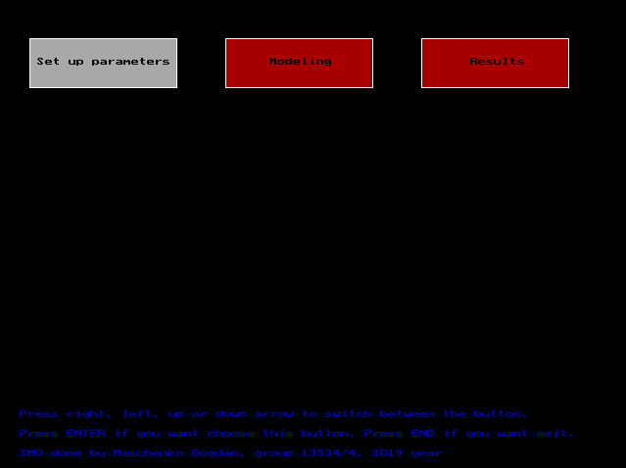

*Рис. 1. Главное меню.*

### Настройка параметров

Настройка параметров моделирования производиться в меню «Config».

* Start lambda, End lambda – границы параметров 1-го потока. Параметр Delta lambda -шаг изменения интенсивности первого источника.
* Kmin – длина реализации.
* Start tay2, End tay2 – параметры 2-го источника.

Ввод данных в текстовых полях:

* Ввод значения – клавиши 0-9 (цифры), точка в качестве разделителя целой и дробной части.
* Подтвердить – клавиша Enter.

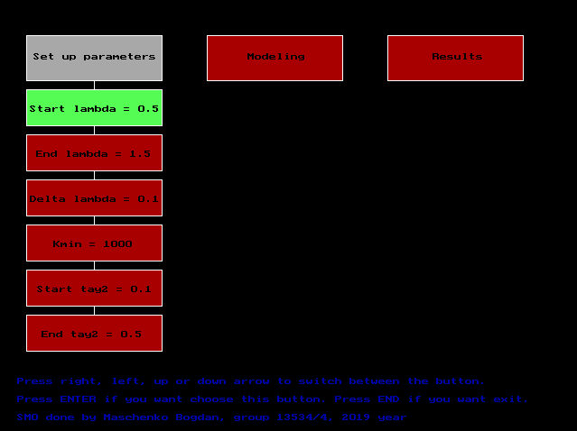

*Рис. 2. Ввод параметров моделирования (меню Set up parameters).*

### Моделирование

Моделирование происходит в меню Modeling.

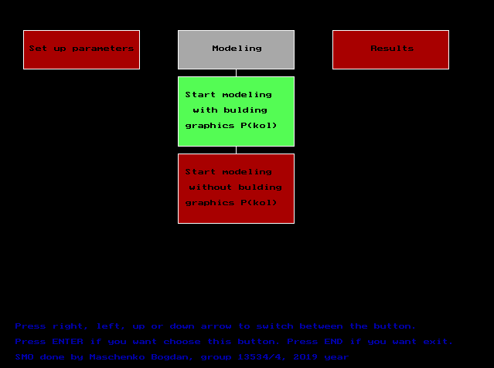

*Рис. 3. Меню Modeling.*

Пользователю предоставляется два варианта:

* Моделирование с отрисовкой online-графика вероятности отказа заявок от второго источника Pотказа 1(k), где k - количество заявок для $=0.5$ 1 симуляции.

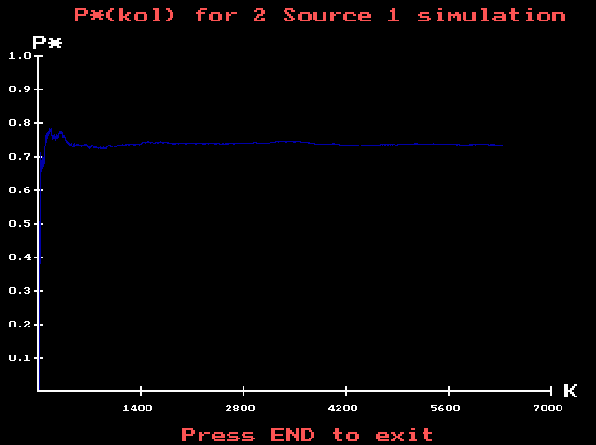

*Рис. 4. Подменю Start modeling with building graphics P(kol).*

* Моделирование без отрисовки online-графика. Simulation started означает, что симуляция началась, Simulation end – закончилась и для дальнейших действий требуется нажать END.

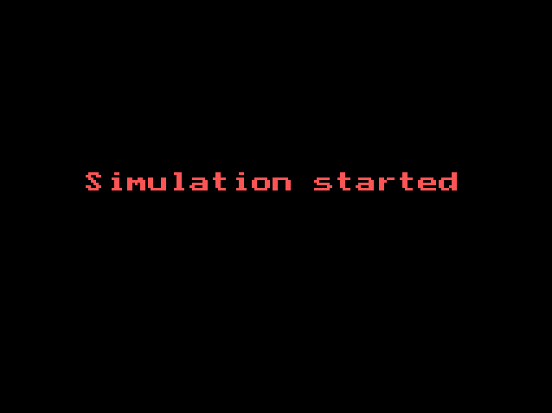

*Рис. 5. Подменю Start modeling without building graphics P(kol). Simulation started.*

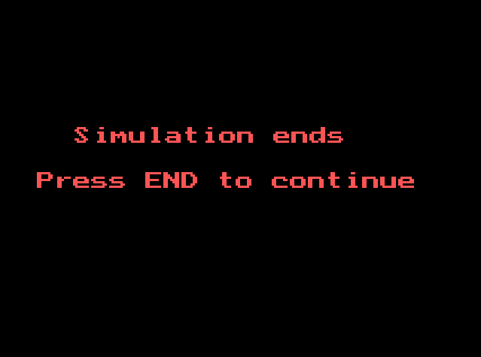

*Рис. 6. Подменю Start modeling without building graphics P(kol). Simulation ends.*

### Результаты

Меню Results содержит три опции: просмотр Table of results, графика зависимости вероятности отказа от интенсивности прибора P(lambda) и графика зависимости математического времени пребывания в системе от интенсивности прибора M(lambda). Подменю Table of results, P(lambda), M(lambda) доступны пользователю только после того, как была промоделирована работа системы, иначе будет выдано текстовое сообщение об ошибке.

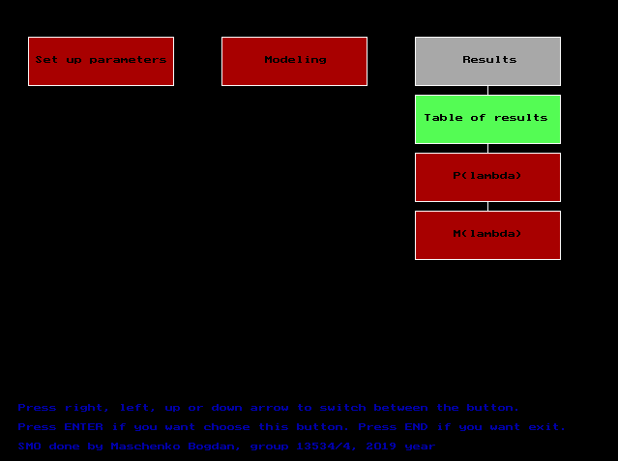

*Рис. 7. Меню Results.*

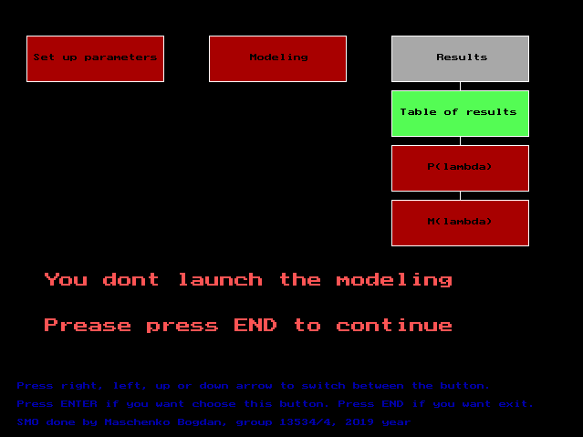

*Рис. 8. Проверка на запуск моделирования.*

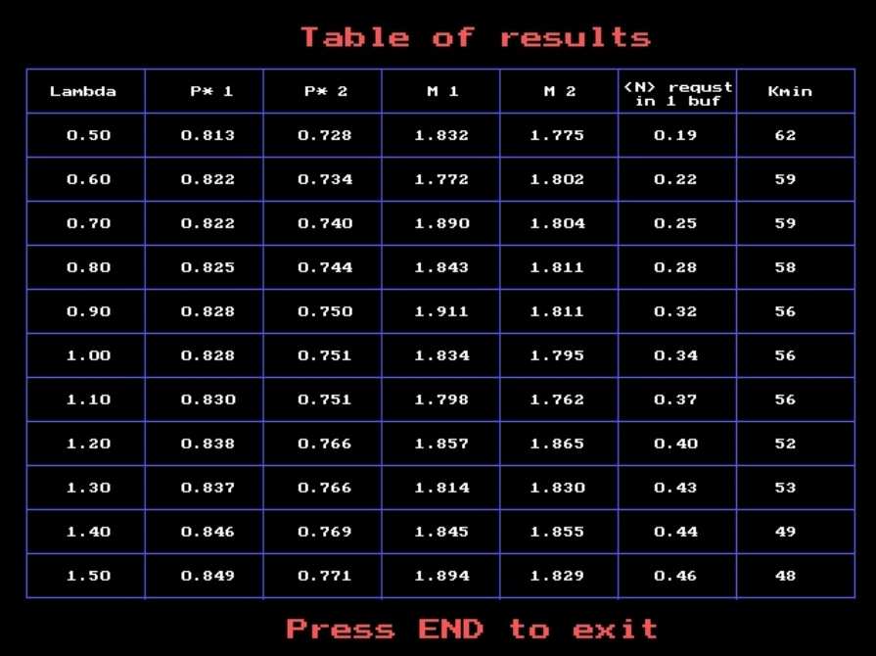

*Рис. 9. Подменю Table of results.*

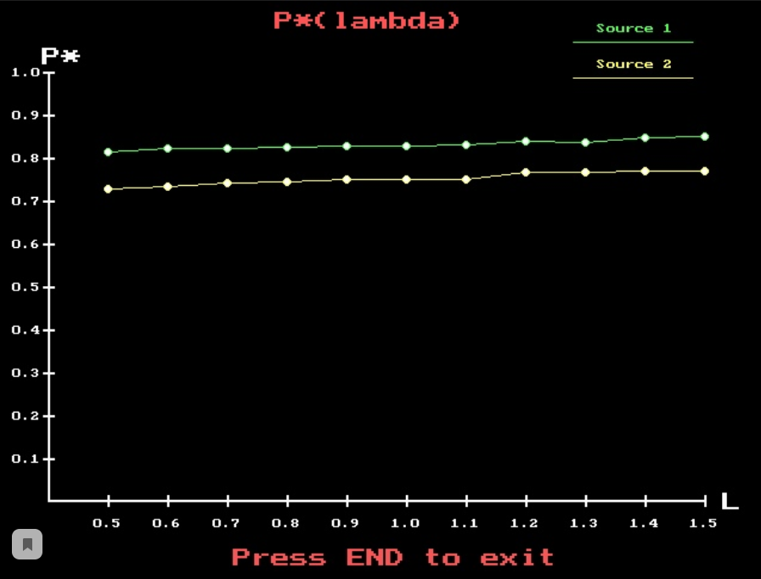

*Рис. 10. Подменю P(lambda).*

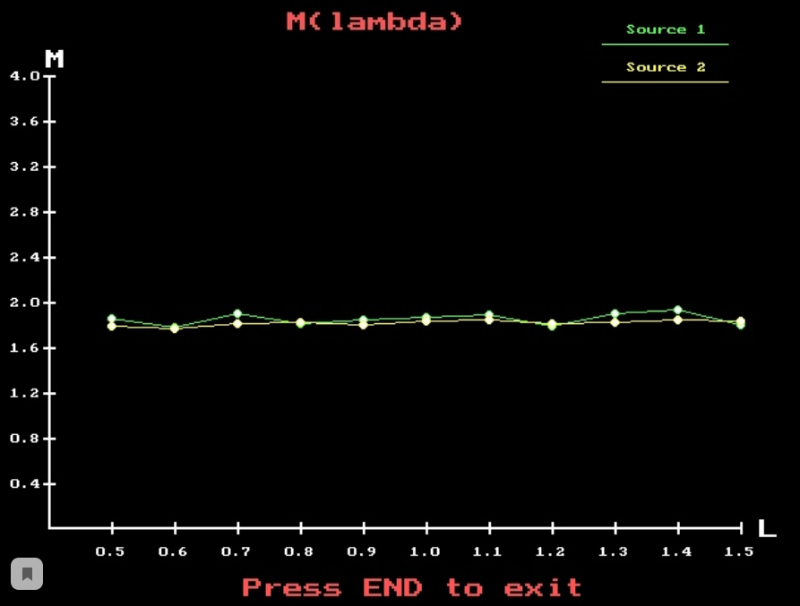

*Рис. 11. Подменю M(lambda).*

## Список использованных источников

1. Веренинов И.А. Программирование на языке высокого уровня: учеб. пособие / И. А. Веренинов. – СПб.: Изд-во Политехн. ун-та, 2013. – 212с.
2. Веренинов И.А. Методические указания к курсовому проектированию по курсу «Алгоритмизация и структурное программирование» для студентов высшей школы программной инженерии ИКНТ. – СПб.: 2016. – 24с.

## Приложение 1. Исходный код программы SMO.PAS

{Main file of project}

program SMO;

uses Menu;

var

MainMenu : p_MainMenu;

BEGIN

randomize;

new(MainMenu, Init);

MainMenu^.launchMainMenu;

END.

## Приложение 2. Исходный код модуля BOOS.PAS

{Implementation of BOOS at the project}

Unit Boos;

Interface

uses Source1, Source2, Writer, Statist, Bas, Device, graph, crt;

type

p_Boos = ^BoosObj;

BoosObj = object

private

{instance of class Source1}

firstSource : p_Source1;

{instance of class Source2}

secondSource : p_Source2;

{instance of class Device}

dev : p_Device;

{instance of class Bas}

basIn : p_Bas;

{instance of class Statistic}

stat : p_Statistic;

{instance of class Writer}

writerIn : p_Writer;

{current iteration}

iteration : longint;

{time of get the request}

tpost : array[1..2] of real;

{long implementation}

kmin : longint;

{const values}

koefStudenta : real;

accuracyOfEstimationOfProbability : real;

public

{initialization the field}

constructor Init(newFirstSource : p_Source1; newSecondSource : p_Source2;

newDev : p_Device; newBasIn : p_Bas;

newStat : p_Statistic; newWriterIn : p_Writer;

koefStudenta_, accuracyOfEstimationOfProbability_ : real);

{reset field of class}

procedure resetField;

{launch event}

procedure launchEvent(indGraph : boolean);

{begin new iteration}

procedure beginNewIteration(indGraph : boolean);

{start simulation}

procedure startSimulation(indGraph : boolean);

{update kmin}

procedure updateKmin(it : longint);

{setter and getter for kmin}

procedure setKmin(kmin_ : longint);

function getKmin : longint;

function getNewKmin(it : longint) : longint;

end;

Implementation

constructor BoosObj.Init;

var

i : longint;

begin

firstSource := newFirstSource;

secondSource := newSecondSource;

dev := newDev;

basIn := newBasIn;

stat := newStat;

writerIn := newWriterIn;

koefStudenta := koefStudenta_;

accuracyOfEstimationOfProbability := accuracyOfEstimationOfProbability_;

iteration := 0;

kmin := 1000;

end;

procedure BoosObj.resetField;

begin

tpost[1] := 0;

tpost[1] := firstSource^.tay(tpost[1]);

tpost[2] := 0;

tpost[2] := secondSource^.tay(tpost[2]);

dev^.clearDevice;

end;

procedure BoosObj.launchEvent;

var

nmin : longint;

numberOfSource : longint;

finishedTime: real;

time: string;

timeR, newObjectTime: real;

sNStr, tStr, iStr, help: string;

prevKol, prevKotk : longint;

begin

if tpost[1] < tpost[2] then

nmin := 1

else

nmin := 2;

str(iteration, iStr);

if (dev^.getWorking = true) and (dev^.getTosv < tpost[nmin]) then

begin

timeR := dev^.getTosv;

str(timeR:4:3, time);

dev^.finishWorking(numberOfSource, finishedTime, newObjectTime);

if newObjectTime <> -1 then

stat^.newAverageExpectionTime(numberOfSource, iteration, timeR - newObjectTime);

stat^.incrementKobr(numberOfSource, iteration);

str(numberOfSource, sNStr);

str(finishedTime:4:3, tStr);

{writerIn^.writeMSG(concat('iteration : ', iStr,' time : ', time,' device finished request ', sNStr, ' from ', tStr));}

exit;

end;

str(nmin, sNStr);

str(tpost[nmin]:4:3, tStr);

if ((nmin = 2) and (indGraph) and (iteration = 1)) then

begin

prevKol := stat^.getKol(2, iteration);

prevKotk := stat^.getKotk(2, iteration);

end;

case basIn^.createNewRequest(nmin, tpost[nmin], iteration) of

1:

begin

{writerIn^.writeMSG(concat('iteration : ', iStr, ' time :', tStr,

' : request from source : ', sNStr, ' was denied'));}

stat^.incrementKotk(nmin, iteration);

end;

2:

begin

{str(stat^.getQuantityRequestInBuffer(nmin, iteration), help);

writerIn^.writeMSG(concat('now quantity for source : ', sNStr, ' is ', help));}

stat^.incrementQuantityRequestInBuffer(nmin, iteration);

{writerIn^.writeMSG(concat('iteration : ', iStr, ' time :',

tStr, ' : request from source : ', sNStr, ' was added'));}

end;

3:

begin

{writerIn^.writeMSG(concat('iteration : ', iStr, ' time : ',

tStr, ' : request from source : ', sNStr,' was passed to device'));}

stat^.newAverageExpectionTime(nmin, iteration, 0);

stat^.incrementRequestGoingInstantlyToDevice(nmin, iteration);

end;

end;

case nmin of

1:

tpost[1] := firstSource^.tay(tpost[1]);

2:

tpost[2] := secondSource^.tay(tpost[2]);

end;

stat^.incrementKol(nmin, iteration);

if ((nmin = 2) and (indGraph) and (iteration = 1)) then

begin

setcolor(blue);

if prevKol > 0 then

line(42 + round((prevKol / (kmin * 7)) * 550), 418 - round((prevKotk / prevKol) * 360),

42 + round((stat^.getKol(2, 1) / (kmin * 7)) * 550),

418 - round((stat^.getKotk(2, 1) / stat^.getKol(2, 1)) * 360))

else

line(42, 418, 42 + round((stat^.getKol(2, 1) / (kmin * 7)) * 550),

418 - round((stat^.getKotk(2, 1) / stat^.getKol(2, 1)) * 360));

end;

end;

procedure BoosObj.beginNewIteration;

var

minKol: longint;

kol: string;

begin

repeat

launchEvent(indGraph);

if (stat^.getKol(1, iteration) < stat^.getKol(2, iteration)) then

minKol := stat^.getKol(1, iteration)

else

minKol := stat^.getKol(2, iteration);

until (minKol >= kmin);

end;

procedure BoosObj.updateKmin;

begin

kmin := round((koefStudenta * (1 - stat^.getProbabilityOfReject(1, it))) /

(accuracyOfEstimationOfProbability * accuracyOfEstimationOfProbability

* stat^.getProbabilityOfReject(1, it)));

end;

procedure BoosObj.startSimulation;

begin

stat^.resetField;

while (firstSource^.getFinallyLambda - firstSource^.getLambda > -0.005) do

begin

inc(iteration);

writerIn^.preIterationMSG(stat, iteration, firstSource^.getLambda, kmin);

resetField;

beginNewIteration(indGraph);

writerIn^.IterationMSG(stat, iteration);

firstSource^.updateLambda;

end;

iteration := 0;

firstSource^.setLambda(0.5);

firstSource^.setFinallyLambda(1.5);

end;

procedure BoosObj.setKmin;

begin

kmin := kmin_;

end;

function BoosObj.getKmin;

begin

getKmin := kmin;

end;

function BoosObj.getNewKmin;

begin

getNewKmin := round((koefStudenta * (1 - stat^.getProbabilityOfReject(1, it))) /

(accuracyOfEstimationOfProbability * accuracyOfEstimationOfProbability

* stat^.getProbabilityOfReject(1, it)));;

end;

BEGIN

END.

## Приложение 3. Исходный код модуля BAS.PAS

{Implementation the units of analysis of the status}

Unit Bas;

Interface

uses Buffer, Device;

type

p_Bas = ^BasObj;

BasObj = object

private

{instance of class Device}

dev : p_Device;

{instance of class Buffer}

buff : p_Buffer;

public

{initialization the field}

constructor Init(newDevice : p_Device; newBuffer : p_Buffer);

{method which create new request with his the index

if return 1 - buffer is busy and request is denied

if return 2 - request is going in buffer

if return 3 - request is going instantly to device }

function createNewRequest(numberOfSource : longint; timeOfSource : real;

iteration : longint) : longint;

end;

Implementation

constructor BasObj.Init;

begin

dev := newDevice;

buff := newBuffer;

end;

function BasObj.createNewRequest;

begin

if dev^.getWorking = false then

begin

dev^.startWorking(numberOfSource, timeOfSource);

createNewRequest := 3;

end

else if buff^.Full = false then

begin

buff^.setRequest(numberOfSource, timeOfSource);

createNewRequest := 2;

end

else

createNewRequest := 1;

end;

BEGIN

END.

## Приложение 4. Исходный код модуля BUFFER.PAS

{Implementation of Buffer with capacity = 2 and without priority}

Unit Buffer;

Interface

type

p_Buffer = ^BufferObj;

BufferObj = object

private

{capacity of Buffer}

capacity : longint;

{length Of Buffer}

indBuf : longint;

{massive number and time of Source in Buffer according}

masBufN : array[1..2] of longint;

masBufT : array[1..2] of real;

public

{initialization the field}

constructor Init(capacity_ : longint);

{return quantity elemnts in Buffer}

function getQuantity : longint;

{check for emptiness and fullness of the buffer according}

function Empty : boolean;

function Full : boolean;

{setter and getter of Request for Buffer according}

procedure setRequest(bufN : longint; bufT : real);

procedure getRequest(var bufN : longint; var bufT : real);

{clear all buffer}

procedure clearBuffer;

end;

Implementation

constructor BufferObj.Init;

begin

capacity := capacity_;

indBuf := 0;

end;

function BufferObj.Empty;

begin

Empty := (indBuf = 0);

end;

function BufferObj.Full;

begin

Full := (indBuf = CAPACITY);

end;

procedure BufferObj.setRequest;

begin

inc(indBuf);

masBufN[indBuf] := bufN;

masBufT[indBuf] := bufT;

end;

procedure BufferObj.getRequest ;

begin

dec(indBuf);

bufN := masBufN[1];

bufT := masBufT[1];

masBufN[1] := masBufN[2];

masBufT[1] := masBufT[2];

end;

procedure BufferObj.clearBuffer;

var

i : longint;

begin

for i := 1 to capacity do

begin

masBufN[i] := 0;

masBufT[i] := 0;

end;

indBuf := 0;

end;

function BufferObj.getQuantity;

begin

getQuantity := indBuf;

end;

BEGIN

END.

## Приложение 5. Исходный код модуля DEVICE.PAS

{Implementation of working our device}

Unit Device;

Interface

uses Buffer;

type

p_Device = ^DeviceObj;

DeviceObj = object

private

{time of start service in the device}

tho : real;

{common time of service}

tayob : real;

{time when device becomes a free}

tosv : real;

{numver of source in device}

numberOfSource : longint;

{check the device is working or not}

working : boolean;

{const lambda of processing}

lambdaObr : real;

{instance of class Buffer}

buff : p_Buffer;

public

{initialization the field}

constructor Init(newBuff : p_Buffer; lambdaObr_ : real);

{getter for field working}

function getWorking : boolean;

{getter for field tho}

function getTho : real;

{getter and maker for field tayob}

function getTayob : real;

{make tayob}

procedure makeTayob;

{getter for field tosv}

function getTosv : real;

{start working}

procedure startWorking(newNumberOfSource : longint; newTho : real);

{finish working}

procedure finishWorking(var finishNumberOfSource : longint;

var finishTime : real;

var newTimeOfNewRequest : real);

{clear the device}

procedure clearDevice;

end;

Implementation

constructor DeviceObj.Init;

begin

buff := newBuff;

tho := 0;

tayob := 0;

tosv := 0;

numberOfSource := 0;

lambdaObr := lambdaObr_ {2};

working := false;

end;

function DeviceObj.getWorking;

begin

getWorking := working;

end;

function DeviceObj.getTho;

begin

getTho := tho;

end;

function DeviceObj.getTayob;

begin

getTayob := tayob;

end;

procedure DeviceObj.makeTayob;

begin

tayob := -(ln(random) / lambdaObr );

end;

function DeviceObj.getTosv;

begin

getTosv := tosv;

end;

procedure DeviceObj.startWorking;

begin

numberOfSource := newNumberOfSource;

tho := newTho;

working := true;

makeTayob;

if tosv > newTho then

tosv := tosv + tayob

else

tosv := newTho + tayob;

end;

procedure DeviceObj.finishWorking;

var

startNewNumberOfSource : longint;

startNewTime : real;

begin

finishNumberOfSource := numberOfSource;

finishTime := tho;

working := false;

if buff^.Empty = true then

newTimeOfNewRequest := -1

else begin

buff^.getRequest(startNewNumberOfSource, startNewTime);

newTimeOfNewRequest := startNewTime;

startWorking(startNewNumberOfSource, startNewTime);

end;

end;

procedure DeviceObj.clearDevice;

begin

tho := 0;

numberOfSource := 0;

working := false;

tosv := 0;

buff^.clearBuffer;

end;

BEGIN

END.

## Приложение 6. Исходный код модуля WRITER.PAS

{Implementation for writer}

Unit Writer;

Interface

uses Statist;

type

p_Writer = ^WriterObj;

WriterObj = object

private

{name for file text}

output: text;

{path to our file}

path : string;

public

{initialization the field}

constructor Init;

{closing file}

destructor Done;

{send message}

procedure writeMSG (msg: string);

{send message about preitertion}

procedure preIterationMSG (stat : p_Statistic; iteration: longint; lambda: real; kmin : longint);

{send message about iteration}

procedure IterationMSG (stat : p_Statistic; iteration: longint);

{send message about average quantity of request in Buffer}

procedure averageQuantityOfRequestInBufferMSG(stat : p_Statistic);

{reset file}

procedure resetFile;

end;

Implementation

constructor WriterObj.Init;

begin

path := 'output.txt';

assign(output, path);

rewrite(output);

end;

destructor WriterObj.Done;

begin

close(output);

end;

procedure WriterObj.writeMSG;

begin

writeln(output, msg);

end;

procedure WriterObj.preIterationMSG;

var

help : string;

begin

writeMSG(' ');

str(iteration, help);

writeMSG(concat('Beginning iteration ', help));

str((round (lambda * 10)) / 10:0:2, help);

writeMSG(concat('lambda = ', help));

str(kmin, help);

writeMSG(concat('kmin = ', help));

writeMSG(' ');

writeMSG('*-*-*-*-*-*-*-*-*-*-*-*-*-*-*-*-*-*-*-*-*-*-*-*-*-*-*-*-*-*-*-*-*-*-*-*-*-*-*-*-');

end;

procedure WriterObj.IterationMSG;

var

help : string;

begin

writeMSG('#################################################################################');

writeMSG(' ');

str(stat^.getKol(1, iteration), help);

writeMSG(concat('kol for first source = ', help));

str(stat^.getKobr(1, iteration), help);

writeMSG(concat('kobr for first source = ', help));

str(stat^.getKotk(1, iteration), help);

writeMSG(concat('kotk for first source = ', help));

str(stat^.getKol(2, iteration), help);

writeMSG(concat('kol for second source = ', help));

str(stat^.getKobr(2, iteration), help);

writeMSG(concat('kobr for second source = ', help));

str(stat^.getKotk(2, iteration), help);

writeMSG(concat('kotk for second source = ', help));

stat^.calculateProbabilityOfReject(iteration);

str(stat^.getProbabilityOfReject(1, iteration):0:2, help);

writeMSG(concat('P for first source = ', help));

str(stat^.getProbabilityOfReject(2, iteration):0:2, help);

writeMSG(concat('P for second source = ', help));

str(stat^.getAverageExpectionTime(1, iteration):4:3, help);

writeMSG(concat('M for first source = ', help));

str(stat^.getAverageExpectionTime(2, iteration):4:3, help);

writeMSG(concat('M for second source = ', help));

str(stat^.getCommonAvExpTime(iteration):4:3, help);

writeMSG(concat('Common M = ', help));

str(stat^.getQuantityRequestInBuffer(1, iteration), help);

writeMSG(concat('Quantity of request in buffer for first source = ', help));

str(stat^.getQuantityRequestInBuffer(2, iteration), help);

writeMSG(concat('Quantity of request in buffer for second source = ', help));

writeMSG(' ');

writeMSG('#################################################################################');

end;

procedure WriterObj.averageQuantityOfRequestInBufferMSG;

var

help : string;

begin

writeMSG(' ');

str(stat^.getAverageQuantityRequestInBuffer(1), help);

writeMSG(concat('Average quantity of request in Buffer for first source = ', help));

str(stat^.getAverageQuantityRequestInBuffer(2), help);

writeMSG(concat('Average quantity of request in Buffer for second source = ', help));

end;

procedure WriterObj.resetFile;

begin

rewrite(output);

end;

BEGIN

END.

## Приложение 7. Исходный код модуля STATIST.PAS

{Implementation for class Statistic which write in file our statistics}

Unit Statist;

Interface

const _NUMBER_OF_ITERATION_ = 11;

type

p_Statistic = ^StatisticObj;

StatisticObj = object

private

{quantity request of source for everyone _NUMBER_OF_ITERATION_}

kol : array[1..2,1.._NUMBER_OF_ITERATION_] of longint;

{quantity requst of source have processed for everyone _NUMBER_OF_ITERATION_}

kobr : array[1..2,1.._NUMBER_OF_ITERATION_] of longint;

{quantity request of source have got reject for everyone _NUMBER_OF_ITERATION_}

kotk : array[1..2,1.._NUMBER_OF_ITERATION_] of longint;

{probability of reject}

probabilityOfReject : array[1..2,0.._NUMBER_OF_ITERATION_] of real;

{common probability Of Reject}

commonProbabilityOfReject : array[0.._NUMBER_OF_ITERATION_] of real;

{counter quantity of request sent in buffer}

quantityOfRequestInBuffer : array[1..2,1.._NUMBER_OF_ITERATION_] of longint;

{average processing time}

averageQuantityRequestInBuffer : array[1..2] of longint;

{average expection time}

averageExpectionTime : array[1..2,1.._NUMBER_OF_ITERATION_] of real;

{common average expection time}

commonAverageExpectionTime : array[1.._NUMBER_OF_ITERATION_] of real;

{request Reached Device}

requestReachedDevice : array[1..2,1.._NUMBER_OF_ITERATION_] of longint;

{request going in device instantly}

requestGoingInstantlyToDevice : array[1..2,1.._NUMBER_OF_ITERATION_] of longint;

public

{initialization our the massive for statistics}

constructor Init(probabilityOfReject_ : real);

{increment quantity request of source}

procedure incrementKol(i, numberOfIteration: longint);

{increment quantity request of source have processed}

procedure incrementKobr(i, numberOfIteration: longint);

{increment quantity request of source have got reject}

procedure incrementKotk(i, numberOfIteration: longint);

{calculate probability of reject}

procedure calculateProbabilityOfReject(numberOfIteration : longint);

{change average processing time after new request in buffer}

procedure calculateAverageQuantityRequestInBuffer(i : longint);

{change average expection time after new request in buffer}

procedure newAverageExpectionTime(i, iteration : longint; newTime : real);

{calculate common average expection time}

procedure calculateAverageExpectionTime(numberOfIteration : longint);

{increment quantityOfRequestInBuffer}

procedure incrementQuantityRequestInBuffer(i, iteration : longint);

{increment quantityOfRequestInBuffer}

procedure incrementRequestGoingInstantlyToDevice(i, iteration : longint);

{reset all field}

procedure resetField;

{getters for all field of class}

function getKol(i, numberOfIteration : longint) : longint;

function getKobr(i, numberOfIteration : longint) : longint;

function getKotk(i, numberOfIteration : longint) : longint;

function getProbabilityOfReject(i, numberOfIteration : longint) : real;

function getCommonProbabilityOfReject(numberOfIteration : longint) : real;

function getAverageQuantityRequestInBuffer(i : longint) : longint;

function getAverageExpectionTime(i, numberOfIteration : longint) : real;

function getCommonAvExpTime(numberOfIteration : longint) : real;

function getQuantityRequestInBuffer(i, numberOfIteration : longint) : longint;

function getRequestGoingInstantlyToDevice(i, numberOfIteration : longint) : longint;

end;

Implementation

constructor StatisticObj.Init;

begin

probabilityOfReject[1,0] := probabilityOfReject_;

probabilityOfReject[2,0] := probabilityOfReject_;

commonProbabilityOfReject[0] := probabilityOfReject_;

end;

procedure StatisticObj.resetField;

var

i, j : longint;

begin

for i := 1 to 2 do

begin

for j := 1 to _NUMBER_OF_ITERATION_ do

begin

kol[i,j] := 0;

kobr[i,j] := 0;

kotk[i,j] := 0;

averageQuantityRequestInBuffer[i] := 0;

averageExpectionTime[i,j] := 0;

quantityOfRequestInBuffer[i,j] := 0;

probabilityOfReject[i,j] := 0;

commonProbabilityOfReject[j] := 0;

commonAverageExpectionTime[j] := 0;

requestReachedDevice[i,j] := 0;

requestGoingInstantlyToDevice[i,j] := 0;

end;

end;

end;

procedure StatisticObj.incrementKol;

begin

inc(kol[i, numberOfIteration]);

end;

procedure StatisticObj.incrementKobr;

begin

inc(kobr[i, numberOfIteration]);

end;

procedure StatisticObj.incrementKotk;

begin

inc(kotk[i, numberOfIteration]);

end;

procedure StatisticObj.calculateProbabilityOfReject;

var

i : longint;

begin

for i := 1 to 2 do

probabilityOfReject[i, numberOfIteration] :=

kotk[i, numberOfIteration] / kol[i, numberOfIteration];

commonProbabilityOfReject[numberOfIteration] :=

(probabilityOfReject[1, numberOfIteration] + probabilityOfReject[2, numberOfIteration]) / 2;

end;

procedure StatisticObj.calculateAverageQuantityRequestInBuffer;

var

temp : longint;

j : longint;

begin

temp := 0;

for j := 1 to _NUMBER_OF_ITERATION_ do

temp :=temp + quantityOfRequestInBuffer[i, j];

averageQuantityRequestInBuffer[i] := round(temp / _NUMBER_OF_ITERATION_);

end;

procedure StatisticObj.newAverageExpectionTime;

begin

averageExpectionTime[i, iteration] := (averageExpectionTime[i, iteration] *

requestReachedDevice[i, iteration] + newTime) / (requestReachedDevice[i, iteration] + 1);

inc(requestReachedDevice[i, iteration]);

end;

procedure StatisticObj.calculateAverageExpectionTime;

begin

commonAverageExpectionTime[numberOfIteration] := (averageExpectionTime[1, numberOfIteration] +

averageExpectionTime[2, numberOfIteration]) / 2;

end;

procedure StatisticObj.incrementQuantityRequestInBuffer;

begin

inc(quantityOfRequestInBuffer[i, iteration]);

end;

procedure StatisticObj.incrementRequestGoingInstantlyToDevice;

begin

inc(requestGoingInstantlyToDevice[i, iteration]);

end;

function StatisticObj.getKol;

begin

getKol := kol[i, numberOfIteration];

end;

function StatisticObj.getKobr;

begin

getKobr := kobr[i, numberOfIteration];

end;

function StatisticObj.getKotk;

begin

getKotk := kotk[i, numberOfIteration];

end;

function StatisticObj.getProbabilityOfReject;

begin

getProbabilityOfReject := kotk[i, numberOfIteration] / kol[i, numberOfIteration];

end;

function StatisticObj.getAverageExpectionTime;

begin

getAverageExpectionTime := averageExpectionTime[i, numberOfIteration];

end;

function StatisticObj.getQuantityRequestInBuffer;

begin

getQuantityRequestInBuffer := quantityOfRequestInBuffer[i, numberOfIteration];

end;

function StatisticObj.getAverageQuantityRequestInBuffer;

begin

calculateAverageQuantityRequestInBuffer(i);

getAverageQuantityRequestInBuffer := averageQuantityRequestInBuffer[i];

end;

function StatisticObj.getCommonAvExpTime;

begin

calculateAverageExpectionTime(numberOfIteration);

getCommonAvExpTime := commonAverageExpectionTime[numberOfIteration];

end;

function StatisticObj.getCommonProbabilityOfReject(numberOfIteration : longint) : real;

begin

getCommonProbabilityOfReject := commonProbabilityOfReject[numberOfIteration];

end;

function StatisticObj.getRequestGoingInstantlyToDevice;

begin

getRequestGoingInstantlyToDevice := requestGoingInstantlyToDevice[i, numberOfIteration];

end;

BEGIN

END.

## Приложение 8. Исходный код модуля SOURCE1.PAS

{Imlementation of Source1}

Unit Source1;

Interface

type

p_Source1 = ^Source1Obj;

Source1Obj = object

private

{data for 1 source}

lambda : real;

deltaLambda : real;

finallyLambda : real;

public

{initialization the field}

constructor Init;

{random value of tay}

function tay(tpost : real) : real;

{getter for lambda}

function getLambda : real;

{getter for delta lambda}

function getDeltaLambda : real;

{getter for finally Lambda}

function getFinallyLambda : real;

{change lambda}

procedure updateLambda;

{setters for field}

procedure setLambda(lambda_ : real);

procedure setDeltaLambda(deltaLambda_ : real);

procedure setFinallyLambda(finallyLambda_ : real);

end;

Implementation

constructor Source1Obj.Init;

begin

lambda := 0.5;

deltaLambda := 0.1;

finallyLambda := 1.5;

end;

function Source1Obj.tay;

begin

tay := tpost - (ln(random) / lambda );

end;

function Source1Obj.getLambda;

begin

getLambda := lambda;

end;

function Source1Obj.getDeltaLambda;

begin

getDeltaLambda := deltaLambda;

end;

function Source1Obj.getFinallyLambda;

begin

getFinallyLambda := finallyLambda;

end;

procedure Source1Obj.updateLambda;

begin

lambda := lambda + deltaLambda;

end;

procedure Source1Obj.setLambda;

begin

lambda := lambda_;

end;

procedure Source1Obj.setDeltaLambda;

begin

deltaLambda := deltaLambda_;

end;

procedure Source1Obj.setFinallyLambda;

begin

finallyLambda := finallyLambda_;

end;

BEGIN

END.

## Приложение 9. Исходный код модуля SOURCE2.PAS

{Implementation for Source2}

Unit Source2;

Interface

type

p_Source2 = ^Source2Obj;

Source2Obj = object

private

{constants for source2}

tay1, tay2 : real;

public

{initialization the field}

constructor Init;

{getters for tay1 and tay2}

function getTay1 : real;

function getTay2 : real;

{random value of tay}

function tay(tpost : real) : real;

{setters for field}

procedure setTay1(tay1_ : real);

procedure setTay2(tay2_ : real);

end;

Implementation

constructor Source2Obj.Init;

begin

tay1 := 0.1;

tay2 := 0.5;

end;

function Source2Obj.getTay1;

begin

getTay1 := tay1;

end;

function Source2Obj.getTay2;

begin

getTay2 := tay2;

end;

function Source2Obj.tay;

begin

tay := tpost + tay1 + (tay2 - tay1) * random;

end;

procedure Source2Obj.setTay1;

begin

tay1 := tay1_;

end;

procedure Source2Obj.setTay2;

begin

tay2 := tay2_;

end;

BEGIN

END.

## Приложение 10. Исходный код модуля MENU.PAS

{Draw menu}

Unit Menu;

Interface

{program Graphic;}

uses graph, crt, SUPM, Bas, Buffer, Device, Boos, Statist,

Writer, Source1, Source2, MenuMod, MenuRes;

type

p_MainMenu = ^MainMenuObj;

MainMenuObj = object

private

{variable for Initgraph}

gh, gm : integer;

{instance of classes}

boosIn : p_Boos;

buff: p_Buffer;

writerIn : p_Writer;

firstSource : p_Source1;

secondSource : p_Source2;

dev : p_Device;

basIn : p_Bas;

stat : p_Statistic;

SubMenuSup : p_SMSUP;

SubMenuMod : p_MenuMod;

SubMenuRes : p_MenuRes;

public

{initialization our the massive for menu}

constructor Init;

{write a tips}

procedure drawHelp;

{draw button of setting params}

procedure drawButtonOfSettingParams(color, fraim : longint);

{draw button of modeling}

procedure drawButtonOfModeling(color, fraim : longint);

{draw button of results}

procedure drawButtonOfResults(color, fraim : longint);

{launch main menu}

procedure launchMainMenu;

end;

Implementation

constructor MainMenuObj.Init;

begin

gm := 0;

gh := 0;

new (firstSource, Init);

new (secondSource, Init);

new (stat, Init(0.9));

new (buff, Init(2));

new (dev, Init(buff, 1));

new (basIn, Init(dev, buff));

new (writerIn, Init);

new (boosIn, Init(firstSource, secondSource, dev, basIn, stat, writerIn, 2.71, 0.1));

new(SubMenuSup, Init(boosIn));

new(SubMenuMod, Init(boosIn, stat));

new(SubMenuRes, Init(stat, firstSource, boosIn));

end;

procedure MainMenuObj.drawHelp;

begin

setcolor(blue);

SetTextStyle(DefaultFont, HorizDir, 1);

OutTextXY(20, 420, 'Press right, left, up or down arrow to switch between the button.');

OutTextXY(20, 440, 'Press ENTER if you want choose this button. Press END if you want exit.');

OutTextXY(20, 460, 'SMO done by Maschenko Bogdan, group 13534/4, 2019 year');

end;

procedure MainMenuObj.drawButtonOfSettingParams;

begin

setcolor(color);

setfillstyle(1, color);

Bar(30, 40, 180, 90);

setcolor(fraim);

Rectangle(30, 40, 180, 90);

setcolor(black);

SetTextStyle(DefaultFont, HorizDir, 1);

OutTextXY(38, 60, 'Set up parameters');

end;

procedure MainMenuObj.drawButtonOfModeling;

begin

setcolor(color);

setfillstyle(1, color);

Bar(230, 40, 380, 90);

setcolor(fraim);

Rectangle(230, 40, 380, 90);

setcolor(black);

SetTextStyle(DefaultFont, HorizDir, 1);

OutTextXY(275, 60, 'Modeling');

end;

procedure MainMenuObj.drawButtonOfResults;

begin

setcolor(color);

setfillstyle(1, color);

Bar(430, 40, 580, 90);

setcolor(fraim);

Rectangle(430, 40, 580, 90);

setcolor(black);

SetTextStyle(DefaultFont, HorizDir, 1);

OutTextXY(480, 60, 'Results');

end;

procedure MainMenuObj.launchMainMenu;

var

button : char;

ind : longint;

begin

Initgraph(gm, gh, '');

drawButtonOfSettingParams(7, 15);

drawButtonOfModeling(4, 15);

drawButtonOfResults(4, 15);

drawHelp;

ind := 1;

button := readkey;

repeat

if ((button = #77) and (ind < 3)) then

inc(ind)

else if ((button = #75) and (ind > 1)) then

dec(ind);

case ind of

1:

begin

drawButtonOfSettingParams(7, 15);

drawButtonOfModeling(4, 15);

drawButtonOfResults(4, 15);

drawHelp;

button := readkey;

if button = #13 then

begin

SubMenuSup^.launchSubmenuOfSUP;

button := readkey;

end;

end;

2:

begin

drawButtonOfSettingParams(4, 15);

drawButtonOfModeling(7,15);

drawButtonOfResults(4, 15);

drawHelp;

button := readkey;

if button = #13 then

begin

SubMenuMod^.launchSubmenuMod;

button := readkey;

end;

end;

3:

begin

drawButtonOfSettingParams(4, 15);

drawButtonOfModeling(4, 15);

drawButtonOfResults(7, 15);

drawHelp;

button := readkey;

if button = #13 then

begin

SubMenuRes^.launchSubmenuRes;

button := readkey;

end;

end;

end;

until button = #79;

writerIn^.averageQuantityOfRequestInBufferMSG(stat);

writerIn^.Done;

CloseGraph;

end;

BEGIN

END.

## Приложение 11. Исходный код модуля SUPM.PAS

{Draw submenu of buttonSup Set up parametres}

Unit SupM;

Interface

uses graph, crt, BOOS, SOURCE1, SOURCE2;

type

p_SMSUP = ^SupObj;

SupObj = object

private

{instance SOURCE1}

firstSource : p_Source1;

{instance SOURCE2}

secondSource : p_Source2;

{instance Boos}

boosIn : p_Boos;

{new kmin}

kmin_ : longint;

{new lambda, delta lambda, finally lambda}

lambda_, deltaLambda_, finallyLambda_ : real;

{new tay1 and tay2}

tay1_, tay2_ : real;

{longint and real --> string}

field : string;

public

{initialization the field}

Constructor Init(boosIn_ : p_Boos);

{draw buttonSup for start lambda}

procedure drawButtonForStartLambda(color, fraim : longint);

{draw buttonSup for end lambda}

procedure drawButtonForEndLambda(color, fraim : longint);

{draw buttonSup for delta lambda}

procedure drawButtonForDeltaLambda(color, fraim : longint);

{draw buttonSup for kmin}

procedure drawButtonForKmin(color, fraim : longint);

{draw buttonSup for start tay2}

procedure drawButtonForStartTay(color, fraim : longint);

{draw buttonSup for end tay2}

procedure drawButtonForEndTay(color, fraim : longint);

{launch submenu of sup}

procedure launchSubmenuOfSUP;

end;

Implementation

constructor SupObj.Init;

begin

new(firstSource, Init);

new(secondSource, Init);

boosIn := boosIn_;

end;

procedure SupObj.drawButtonForStartLambda;

begin

setcolor(color);

setfillstyle(1, color);

Bar(30, 100, 180, 140);

setcolor(fraim);

Rectangle(30, 100, 180, 140);

setcolor(black);

SetTextStyle(DefaultFont, HorizDir, 1);

str(firstSource^.getLambda:2:1, field);

OutTextXY(34, 118, concat('Start lambda = ', field));

setcolor(fraim);

line(105, 100, 105, 91);

end;

procedure SupObj.drawButtonForEndLambda;

begin

setcolor(color);

setfillstyle(1, color);

Bar(30, 150, 180, 190);

setcolor(fraim);

Rectangle(30, 150, 180, 190);

setcolor(black);

SetTextStyle(DefaultFont, HorizDir, 1);

str(firstSource^.getFinallyLambda:2:1, field);

OutTextXY(41, 168, concat('End lambda = ', field));

setcolor(fraim);

line(105, 150, 105, 140);

end;

procedure SupObj.drawButtonForDeltaLambda;

begin

setcolor(color);

setfillstyle(1, color);

Bar(30, 200, 180, 240);

setcolor(fraim);

Rectangle(30, 200, 180, 240);

setcolor(black);

SetTextStyle(DefaultFont, HorizDir, 1);

str(firstSource^.getDeltaLambda:2:1, field);

OutTextXY(34, 218, concat('Delta lambda = ', field));

setcolor(fraim);

line(105, 200, 105, 190);

end;

procedure SupObj.drawButtonForKmin;

begin

setcolor(color);

setfillstyle(1, color);

Bar(30, 250, 180, 290);

setcolor(fraim);

Rectangle(30, 250, 180, 290);

setcolor(black);

SetTextStyle(DefaultFont, HorizDir, 1);

str(boosIn^.getKmin, field);

OutTextXY(60, 268, concat('Kmin = ', field));

setcolor(fraim);

line(105, 250, 105, 240);

end;

procedure SupObj.drawButtonForStartTay;

begin

setcolor(color);

setfillstyle(1, color);

Bar(30, 300, 180, 340);

setcolor(fraim);

Rectangle(30, 300, 180, 340);

setcolor(black);

SetTextStyle(DefaultFont, HorizDir, 1);

str(secondSource^.getTay1:2:1, field);

OutTextXY(42, 318, concat('Start tay2 = ', field));

setcolor(fraim);

line(105, 300, 105, 290);

end;

procedure SupObj.drawButtonForEndTay;

begin

setcolor(color);

setfillstyle(1, color);

Bar(30, 350, 180, 390);

setcolor(fraim);

Rectangle(30, 350, 180, 390);

setcolor(black);

SetTextStyle(DefaultFont, HorizDir, 1);

str(secondSource^.getTay2:2:1, field);

OutTextXY(47, 368, concat('End tay2 = ', field));

setcolor(fraim);

line(105, 350, 105, 340);

end;

procedure SupObj.launchSubmenuOfSUP;

var

buttonSup : char;

indSup : longint;

begin

drawButtonForStartLambda(10, 15);

drawButtonForEndLambda(4, 15);

drawButtonForDeltaLambda(4, 15);

drawButtonForKmin(4, 15);

drawButtonForStartTay(4, 15);

drawButtonForEndTay(4, 15);

indSup := 1;

buttonSup := readkey;

repeat

if ((buttonSup = #80) and (indSup < 6)) then

inc(indSup)

else if ((buttonSup = #72) and (indSup > 1)) then

dec(indSup);

case indSup of

1:

begin

drawButtonForStartLambda(10, 15);

drawButtonForEndLambda(4, 15);

drawButtonForDeltaLambda(4, 15);

drawButtonForKmin(4, 15);

drawButtonForStartTay(4, 15);

drawButtonForEndTay(4, 15);

buttonSup := readkey;

if buttonSup = #13 then

begin

read(lambda_);

setfillstyle(1, black);

Bar(0, 0, 640, 15);

firstSource^.setLambda(lambda_);

drawButtonForStartLambda(10, 15);

buttonSup := readkey;

end;

end;

2:

begin

drawButtonForStartLambda(4, 15);

drawButtonForEndLambda(10, 15);

drawButtonForDeltaLambda(4, 15);

drawButtonForKmin(4, 15);

drawButtonForStartTay(4, 15);

drawButtonForEndTay(4, 15);

buttonSup := readkey;

if buttonSup = #13 then

begin

read(finallyLambda_);

setfillstyle(1, black);

Bar(0, 0, 640, 15);

firstSource^.setFinallyLambda(finallyLambda_);

drawButtonForEndLambda(10, 15);

buttonSup := readkey;

end;

end;

3:

begin

drawButtonForStartLambda(4, 15);

drawButtonForEndLambda(4, 15);

drawButtonForDeltaLambda(10, 15);

drawButtonForKmin(4,15);

drawButtonForStartTay(4, 15);

drawButtonForEndTay(4, 15);

buttonSup := readkey;

if buttonSup = #13 then

begin

read(deltaLambda_);

setfillstyle(1, black);

Bar(0, 0, 640, 15);

firstSource^.setDeltaLambda(deltaLambda_);

drawButtonForDeltaLambda(10, 15);

buttonSup := readkey;

end;

end;

4:

begin

drawButtonForStartLambda(4, 15);

drawButtonForEndLambda(4, 15);

drawButtonForDeltaLambda(4, 15);

drawButtonForKmin(10, 15);

drawButtonForStartTay(4, 15);

drawButtonForEndTay(4, 15);

buttonSup := readkey;

if buttonSup = #13 then

begin

read(kmin_);

setfillstyle(1, black);

Bar(0, 0, 640, 15);

boosIn^.setKmin(kmin_);

drawButtonForKmin(10, 15);

buttonSup := readkey;

end;

end;

5:

begin

drawButtonForStartLambda(4, 15);

drawButtonForEndLambda(4, 15);

drawButtonForDeltaLambda(4, 15);

drawButtonForKmin(4, 15);

drawButtonForStartTay(10, 15);

drawButtonForEndTay(4, 15);

buttonSup := readkey;

if buttonSup = #13 then

begin

read(tay1_);

setfillstyle(1, black);

Bar(0, 0, 640, 15);

secondSource^.setTay1(tay1_);

drawButtonForStartTay(10, 15);

buttonSup := readkey;

end;

end;

6:

begin

drawButtonForStartLambda(4, 15);

drawButtonForEndLambda(4, 15);

drawButtonForDeltaLambda(4, 15);

drawButtonForKmin(4, 15);

drawButtonForStartTay(4, 15);

drawButtonForEndTay(10, 15);

buttonSup := readkey;

if buttonSup = #13 then

begin

read(tay2_);

setfillstyle(1, black);

Bar(0, 0, 640, 15);

secondSource^.setTay2(tay2_);

drawButtonForEndTay(10, 15);

buttonSup := readkey;

end;

end;

end;

if buttonSup = #79 then

begin

drawButtonForStartLambda(0, 0);

drawButtonForEndLambda(0, 0);

drawButtonForDeltaLambda(0, 0);

drawButtonForKmin(0, 0);

drawButtonForStartTay(0, 0);

drawButtonForEndTay(0, 0);

end;

until buttonSup = #79;

end;

BEGIN

END.

## Приложение 12. Исходный код модуля MENUMOD.PAS

{Draw submenu for button modeling}

Unit MenuMod;

Interface

uses graph, crt, Statist, Boos;

type

p_MenuMod = ^MenuModObj;

MenuModObj = object

private

{instance of class Boos and Statist}

stat : p_Statistic;

boosIn : p_Boos;

public

{initialization the field}

constructor Init(boosIn_ : p_Boos; stat_ : p_Statistic);

{draw osi koordinat for graphics}

procedure drawOsKoord;

{draw button modeling with building graphics P(kol)}

procedure drawButtonModelingWithGraphics(color, fraim : longint);

{draw button modeling without building graphics P(kol)}

procedure drawButtonModelingWithoutGraphics(color, fraim : longint);

{write a tips}

procedure drawHelp;

{draw button of setting params}

procedure drawButtonOfSettingParams(color, fraim : longint);

{draw button of modeling}

procedure drawButtonOfModeling(color, fraim : longint);

{draw button of results}

procedure drawButtonOfResults(color, fraim : longint);

{draw black background}

procedure drawBackground;

{launch submenu of button modeling}

procedure launchSubmenuMod;

end;

Implementation

constructor MenuModObj.Init;

begin

boosIn := boosIn_;

stat := stat_;

end;

procedure MenuModObj.drawButtonModelingWithGraphics;

begin

setcolor(color);

setfillstyle(1, color);

Bar(230, 100, 380, 190);

setcolor(fraim);

Rectangle(230, 100, 380, 190);

setcolor(black);

SetTextStyle(DefaultFont, HorizDir, 1);

OutTextXY(240, 120, 'Start modeling');

OutTextXY(250, 140, 'with bulding');

OutTextXY(240, 160, 'graphics P(kol)');

setcolor(fraim);

line(305, 100, 305, 91);

end;

procedure MenuModObj.drawButtonModelingWithoutGraphics;

begin

setcolor(color);

setfillstyle(1, color);

Bar(230, 200, 380, 290);

setcolor(fraim);

Rectangle(230, 200, 380, 290);

setcolor(black);

SetTextStyle(DefaultFont, HorizDir, 1);

OutTextXY(240, 220, 'Start modeling');

OutTextXY(245, 240, 'without bulding');

OutTextXY(240, 260, 'graphics P(kol)');

setcolor(fraim);

line(305, 200, 305, 190);

end;

procedure MenuModObj.drawHelp;

begin

setcolor(blue);

SetTextStyle(DefaultFont, HorizDir, 1);

OutTextXY(20, 420, 'Press right, left, up or down arrow to switch between the button.');

OutTextXY(20, 440, 'Press ENTER if you want choose this button. Press END if you want exit.');

OutTextXY(20, 460, 'SMO done by Maschenko Bogdan, group 13534/4, 2019 year');

end;

procedure MenuModObj.drawButtonOfSettingParams;

begin

setcolor(color);

setfillstyle(1, color);

Bar(30, 40, 180, 90);

setcolor(fraim);

Rectangle(30, 40, 180, 90);

setcolor(black);

SetTextStyle(DefaultFont, HorizDir, 1);

OutTextXY(38, 60, 'Set up parameters');

end;

procedure MenuModObj.drawButtonOfModeling;

begin

setcolor(color);

setfillstyle(1, color);

Bar(230, 40, 380, 90);

setcolor(fraim);

Rectangle(230, 40, 380, 90);

setcolor(black);

SetTextStyle(DefaultFont, HorizDir, 1);

OutTextXY(275, 60, 'Modeling');

end;

procedure MenuModObj.drawButtonOfResults;

begin

setcolor(color);

setfillstyle(1, color);

Bar(430, 40, 580, 90);

setcolor(fraim);

Rectangle(430, 40, 580, 90);

setcolor(black);

SetTextStyle(DefaultFont, HorizDir, 1);

OutTextXY(480, 60, 'Results');

end;

procedure MenuModObj.drawBackground;

begin

setcolor(black);

setfillstyle(1, black);

Bar(0, 0, 640, 480);

end;

procedure MenuModObj.drawOsKoord;

var

button : char;

i : longint;

help : string[10];

begin

drawBackground;

setcolor(12);

SetTextStyle(DefaultFont, HorizDir, 2);

OutTextXY(80, 10, 'P*(kol) for 2 Source 1 simulation');

OutTextXY(195, 460, 'Press END to exit');

setfillstyle(1, white);

Bar(40, 60, 41, 420);

Bar(40, 419, 590, 420);

setcolor(15);

SetTextStyle(DefaultFont, HorizDir, 2);

OutTextXY(35, 40, 'P*');

OutTextXY(605, 413, 'K');

SetTextStyle(DefaultFont, HorizDir, 1);

for i := 1 to 10 do

begin

Bar(36, 60 + (i - 1) * 36, 45, 61 + (i - 1) * 36);

str((0.1 * i):2:1, help);

OutTextXY(10, 57 + (10 - i) * 36, help);

end;

for i := 1 to 5 do

begin

Bar(40 + 110 * i, 415, 41 + 110 * i, 424);

str(round((boosIn^.getKmin / 5) * 7 * i), help);

OutTextXY(22 + 110 * i, 435, help);

end;

end;

procedure MenuModObj.launchSubmenuMod;

var

buttonMod : char;

indMod : longint;

begin

drawButtonModelingWithGraphics(10, 15);

drawButtonModelingWithoutGraphics(4, 15);

indMod := 1;

buttonMod := readkey;

repeat

if ((buttonMod = #80) and (indMod < 2)) then

inc(indMod)

else if ((buttonMod = #72) and (indMod > 1)) then

dec(indMod);

case indMod of

1:

begin

drawButtonModelingWithGraphics(10, 15);

drawButtonModelingWithoutGraphics(4, 15);

buttonMod := readkey;

if buttonMod = #13 then

begin

drawOsKoord;

boosIn^.startSimulation(true);

repeat

buttonMod := readkey;

until buttonMod = #79;

drawBackground;

drawButtonOfSettingParams(4, 15);

drawButtonOfModeling(7,15);

drawButtonOfResults(4, 15);

drawHelp;

drawButtonModelingWithGraphics(10, 15);

drawButtonModelingWithoutGraphics(4, 15);

buttonMod := readkey;

end;

end;

2:

begin

drawButtonModelingWithGraphics(4, 15);

drawButtonModelingWithoutGraphics(10, 15);

buttonMod := readkey;

if buttonMod = #13 then

begin

drawBackground;

setcolor(12);

SetTextStyle(DefaultFont, HorizDir, 3);

OutTextXY(100, 200, 'Simulation started');

boosIn^.startSimulation(false);

delay(25000);

drawBackground;

setcolor(12);

SetTextStyle(DefaultFont, HorizDir, 3);

OutTextXY(100, 170, 'Simulation ends');

OutTextXY(50, 230, 'Press END to continue');

repeat

buttonMod := readkey;

until buttonMod = #79;

drawBackground;

drawButtonOfSettingParams(4, 15);

drawButtonOfModeling(7,15);

drawButtonOfResults(4, 15);

drawHelp;

drawButtonModelingWithGraphics(4, 15);

drawButtonModelingWithoutGraphics(10, 15);

buttonMod := readkey;

end;

end;

end;

if buttonMod = #79 then

begin

drawButtonModelingWithGraphics(0, 0);

drawButtonModelingWithoutGraphics(0, 0);

end;

until buttonMod = #79;

end;

BEGIN

END.

## Приложение 13. Исходный код модуля MENURES.PAS

{Draw submenu for button modeling}

Unit MenuRes;

Interface

uses graph, crt, Statist, Source1, Boos;

type

p_MenuRes = ^MenuResObj;

MenuResObj = object

private

{instance for class Source1 and Statistic}

stat : p_Statistic;

firstSource : p_Source1;

booisIn : p_Boos;

public

{initialization the field}

constructor Init(stat_ : p_Statistic; firstSource_ : p_Source1; booisIn_ : p_Boos);

{draw lines P}

procedure drawLinesP(color, source : longint);

{draw lines M}

procedure drawLinesM(color, source : longint);

{draw black background}

procedure drawBackground;

{draw table of results}

procedure drawTableOfResults;

{draw graphics P*}

procedure drawGraphicsP;

{draw graphics M}

procedure drawGraphicsM;

{draw button table of result}

procedure drawButtonTableOfResults(color, fraim : longint);

{draw button P(lambda)}

procedure drawButtonP(color, fraim : longint);

{draw button M(lambda)}

procedure drawButtonM(color, fraim : longint);

{draw warning}

procedure drawWarning;

{write a tips}

procedure drawHelp;

{draw button of setting params}

procedure drawButtonOfSettingParams(color, fraim : longint);

{draw button of modeling}

procedure drawButtonOfModeling(color, fraim : longint);

{draw button of results}

procedure drawButtonOfResults(color, fraim : longint);

{launch submenu of result}

procedure launchSubmenuRes;

end;

Implementation

{initialization the field}

constructor MenuResObj.Init;

begin

stat := stat_;

firstSource := firstSource_;

booisIn := booisIn_;

end;

procedure MenuResObj.drawBackground;

begin

setcolor(black);

setfillstyle(1, black);

Bar(0, 0, 640, 480);

end;

procedure MenuResObj.drawWarning;

var

button : char;

begin

setcolor(12);

SetTextStyle(DefaultFont, HorizDir, 2);

OutTextXY(50, 300, 'You dont launch the modeling');

OutTextXY(50, 350, 'Prease press END to continue');

repeat

button := readkey;

until button = #79;

setfillstyle(1, black);

Bar(45, 290, 400, 400);

end;

procedure MenuResObj.drawTableOfResults;

var

button : char;

iteration : longint;

help : string;

begin

if stat^.getKol(1, 1) = 0 then

begin

drawWarning;

exit;

end;

drawBackground;

setcolor(12);

SetTextStyle(DefaultFont, HorizDir, 2);

OutTextXY(220, 20, 'Table of results');

OutTextXY(210, 450, 'Press END to exit');

setcolor(9);

Rectangle(20, 50, 622, 434);

for iteration:= 1 to 11 do

begin

line(20, 50 + iteration * 32, 622, 50 + iteration * 32);

end;

for iteration:= 1 to 6 do

begin

line(20 + iteration * 86, 50, 20 + iteration * 86, 435);

end;

SetTextStyle(DefaultFont, HorizDir, 1);

setcolor(15);

OutTextXY(38, 63, 'Lambda');

OutTextXY(140, 63, 'P* 1');

OutTextXY(223, 63, 'P* 2');

OutTextXY(312, 63, 'M 1');

OutTextXY(397, 63, 'M 2');

OutTextXY(455, 60, '<N> requst');

OutTextXY(462, 70, 'in 1 buf');

OutTextXY(560, 63, 'Kmin');

for iteration := 1 to 11 do

begin

str((firstSource^.getLambda + (iteration - 1) *

firstSource^.getDeltaLambda):3:2, help);

OutTextXY(50, 63 + iteration * 32, help);

str((stat^.getProbabilityOfReject(1, iteration)):4:3, help);

OutTextXY(133, 63 + iteration * 32, help);

str((stat^.getProbabilityOfReject(2, iteration)):4:3, help);

OutTextXY(218, 63 + iteration * 32, help);

str(stat^.getAverageExpectionTime(1, iteration):4:3, help);

OutTextXY(303, 63 + iteration * 32, help);

str(stat^.getAverageExpectionTime(2, iteration):4:3, help);

OutTextXY(387, 63 + iteration * 32, help);

str(((stat^.getQuantityRequestInBuffer(1, iteration)/

(stat^.getKobr(1, iteration) + stat^.getKobr(2, iteration) -

stat^.getRequestGoingInstantlyToDevice(1, iteration) -

stat^.getRequestGoingInstantlyToDevice(2, iteration)))*2):3:2, help);

OutTextXY(477, 63 + iteration * 32, help);

str(booisIn^.getNewKmin(iteration), help);

OutTextXY(565, 63 + iteration * 32, help);

end;

repeat

button := readkey;

until button = #79;

end;

procedure MenuResObj.drawLinesP;

var

i : longint;

begin

setcolor(color);

for i := 1 to 10 do

begin

line(40 + 50 * i, 420 - round(stat^.getProbabilityOfReject(source, i) * 360),

40 + 50 * (i + 1), 420 - round(stat^.getProbabilityOfReject(source, (i + 1)) * 360));

FillEllipse(40 + 50 * i, 420 - round(stat^.getProbabilityOfReject(source, i) * 360), 3, 3);

FillEllipse(40 + 50 * (i + 1), 420 - round(stat^.getProbabilityOfReject(source, (i + 1)) * 360), 3, 3);

end;

end;

procedure MenuResObj.drawGraphicsP;

var

button : char;

iteration, i : longint;

help : string;

begin

if stat^.getKol(1, 1) = 0 then

begin

drawWarning;

exit;

end;

drawBackground;

setcolor(12);

SetTextStyle(DefaultFont, HorizDir, 2);

OutTextXY(230, 10, 'P*(lambda)');

OutTextXY(195, 460, 'Press END to exit');

setfillstyle(1, white);

Bar(40, 60, 41, 420);

Bar(40, 419, 590, 420);

setcolor(15);

SetTextStyle(DefaultFont, HorizDir, 2);

OutTextXY(35, 40, 'P*');

OutTextXY(605, 413, 'L');

SetTextStyle(DefaultFont, HorizDir, 1);

for i := 1 to 10 do

begin

Bar(36, 60 + (i - 1) * 36, 45, 61 + (i - 1) * 36);

str((0.1 * i):2:1, help);

OutTextXY(10, 57 + (10 - i) * 36, help);

end;

for iteration := 1 to 11 do

begin

Bar(40 + 50 * iteration, 415, 41 + 50 * iteration, 424);

str((firstSource^.getLambda + firstSource^.getDeltaLambda *

(iteration - 1)):2:1, help);

OutTextXY(28 + 50 * iteration, 435, help);

end;

SetTextStyle(DefaultFont, HorizDir, 1);

setcolor(10);

line(480, 35, 580, 35);

OutTextXY(500, 20, 'Source 1');

setcolor(14);

line(480, 65, 580, 65);

OutTextXY(500, 50, 'Source 2');

drawLinesP(10, 1);

drawLinesP(14, 2);

repeat

button := readkey;

until button = #79;

end;

procedure MenuResObj.drawLinesM;

var

i : longint;

begin

setcolor(color);

for i := 1 to 10 do

begin

line(40 + 50 * i, 420 - round((stat^.getAverageExpectionTime(source, i) / 4) * 360),

40 + 50 * (i + 1), 420 - round((stat^.getAverageExpectionTime(source, (i + 1)) / 4) * 360));

FillEllipse(40 + 50 * i, 420 - round((stat^.getAverageExpectionTime(source, i) / 4) * 360), 3, 3);

FillEllipse(40 + 50 * (i + 1), 420 - round((stat^.getAverageExpectionTime(source, (i + 1)) / 4) * 360), 3, 3);

end;

end;

procedure MenuResObj.drawGraphicsM;

var

button : char;

iteration, i : longint;

help : string;

begin

if stat^.getKol(1, 1) = 0 then

begin

drawWarning;

exit;

end;

drawBackground;

setcolor(12);

SetTextStyle(DefaultFont, HorizDir, 2);

OutTextXY(230, 10, 'M(lambda)');

OutTextXY(195, 460, 'Press END to exit');

setfillstyle(1, white);

Bar(40, 60, 41, 420);

Bar(40, 419, 590, 420);

setcolor(15);

SetTextStyle(DefaultFont, HorizDir, 2);

OutTextXY(38, 40, 'M');

OutTextXY(605, 413, 'L');

SetTextStyle(DefaultFont, HorizDir, 1);

for i := 1 to 10 do

begin

Bar(36, 60 + (i - 1) * 36, 45, 61 + (i - 1) * 36);

str((0.4 * i):2:1, help);

OutTextXY(10, 57 + (10 - i) * 36, help);

end;

for iteration := 1 to 11 do

begin

Bar(40 + 50 * iteration, 415, 41 + 50 * iteration, 424);

str((firstSource^.getLambda + firstSource^.getDeltaLambda *

(iteration - 1)):2:1, help);

OutTextXY(28 + 50 * iteration, 435, help);

end;

SetTextStyle(DefaultFont, HorizDir, 1);

setcolor(10);

line(480, 35, 580, 35);

OutTextXY(500, 20, 'Source 1');

setcolor(14);

line(480, 65, 580, 65);

OutTextXY(500, 50, 'Source 2');

drawLinesM(10, 1);

drawLinesM(14, 2);

repeat

button := readkey;

until button = #79;

end;

procedure MenuResObj.drawButtonTableOfResults;

begin

setcolor(color);

setfillstyle(1, color);

Bar(430, 100, 580, 150);

setcolor(fraim);

Rectangle(430, 100, 580, 150);

setcolor(black);

SetTextStyle(DefaultFont, HorizDir, 1);

OutTextXY(440, 120, 'Table of results');

setcolor(fraim);

line(505, 100, 505, 91);

end;

procedure MenuResObj.drawButtonP;

begin

setcolor(color);

setfillstyle(1, color);

Bar(430, 160, 580, 210);

setcolor(fraim);

Rectangle(430, 160, 580, 210);

setcolor(black);

SetTextStyle(DefaultFont, HorizDir, 1);

OutTextXY(470, 180, 'P(lambda)');

setcolor(fraim);

line(505, 160, 505, 150);

end;

procedure MenuResObj.drawButtonM;

begin

setcolor(color);

setfillstyle(1, color);

Bar(430, 220, 580, 270);

setcolor(fraim);

Rectangle(430, 220, 580, 270);

setcolor(black);

SetTextStyle(DefaultFont, HorizDir, 1);

OutTextXY(470, 240, 'M(lambda)');

setcolor(fraim);

line(505, 220, 505, 210);

end;

procedure MenuResObj.drawHelp;

begin

setcolor(blue);

SetTextStyle(DefaultFont, HorizDir, 1);

OutTextXY(20, 420, 'Press right, left, up or down arrow to switch between the button.');

OutTextXY(20, 440, 'Press ENTER if you want choose this button. Press END if you want exit.');

OutTextXY(20, 460, 'SMO done by Maschenko Bogdan, group 13534/4, 2019 year');

end;

procedure MenuResObj.drawButtonOfSettingParams;

begin

setcolor(color);

setfillstyle(1, color);

Bar(30, 40, 180, 90);

setcolor(fraim);

Rectangle(30, 40, 180, 90);

setcolor(black);

SetTextStyle(DefaultFont, HorizDir, 1);

OutTextXY(38, 60, 'Set up parameters');

end;

procedure MenuResObj.drawButtonOfModeling;

begin

setcolor(color);

setfillstyle(1, color);

Bar(230, 40, 380, 90);

setcolor(fraim);

Rectangle(230, 40, 380, 90);

setcolor(black);

SetTextStyle(DefaultFont, HorizDir, 1);

OutTextXY(275, 60, 'Modeling');

end;

procedure MenuResObj.drawButtonOfResults;

begin

setcolor(color);

setfillstyle(1, color);

Bar(430, 40, 580, 90);

setcolor(fraim);

Rectangle(430, 40, 580, 90);

setcolor(black);

SetTextStyle(DefaultFont, HorizDir, 1);

OutTextXY(480, 60, 'Results');

end;

procedure MenuResObj.launchSubmenuRes;

var

buttonRes : char;

indRes : longint;

begin

drawButtonTableOfResults(10, 15);

drawButtonP(4, 15);

drawButtonM(4, 15);

indRes := 1;

buttonRes := readkey;

repeat

if ((buttonRes = #80) and (indRes < 3)) then

inc(indRes)

else if ((buttonRes = #72) and (indRes > 1)) then

dec(indRes);

case indRes of

1:

begin

drawButtonTableOfResults(10, 15);

drawButtonP(4, 15);

drawButtonM(4, 15);

buttonRes := readkey;

if buttonRes = #13 then

begin

drawTableOfResults;

drawBackground;

drawButtonOfSettingParams(4, 15);

drawButtonOfModeling(4,15);

drawButtonOfResults(7, 15);

drawHelp;

drawButtonTableOfResults(10, 15);

drawButtonP(4, 15);

drawButtonM(4, 15);

buttonRes := readkey;

end;

end;

2:

begin

drawButtonTableOfResults(4, 15);

drawButtonP(10, 15);

drawButtonM(4, 15);

buttonRes := readkey;

if buttonRes = #13 then

begin

drawGraphicsP;

drawBackground;

drawButtonOfSettingParams(4, 15);

drawButtonOfModeling(4,15);

drawButtonOfResults(7, 15);

drawHelp;

drawButtonTableOfResults(4, 15);

drawButtonP(10, 15);

drawButtonM(4, 15);

buttonRes := readkey;

end;

end;

3:

begin

drawButtonTableOfResults(4, 15);

drawButtonP(4, 15);

drawButtonM(10, 15);

buttonRes := readkey;

if buttonRes = #13 then

begin

drawGraphicsM;

drawBackground;

drawButtonOfSettingParams(4, 15);

drawButtonOfModeling(4,15);

drawButtonOfResults(7, 15);

drawHelp;

drawButtonTableOfResults(4, 15);

drawButtonP(4, 15);

drawButtonM(10, 15);

buttonRes := readkey;

end;

end;

end;

if buttonRes = #79 then

begin

drawButtonTableOfResults(0, 0);

drawButtonP(0, 0);

drawButtonM(0, 0);

end;

until buttonRes = #79;

end;

BEGIN

END.